Restaurant Robot Navigation System

Overview
The Restaurant Robot Navigation System is a Python-based ROS (Robot Operating System) application that enables a robot to navigate between predefined locations in a restaurant. The robot can move between home, kitchen, and multiple tables, while awaiting user confirmation before proceeding with deliveries.

Features
- Uses ROS Action Server (move_base) to navigate.
- Accepts orders with multiple delivery locations.
- Waits for user confirmation with a timeout mechanism before proceeding.
- Automatically returns to home if confirmation is not received.
- Supports multiple orders in a single session.

Installation

Prerequisites
- ROS (Robot Operating System) installed (tested with ROS Noetic or ROS Melodic).
- move_base package must be installed and properly configured.
- A working robot localization and mapping setup.

Steps to Install
- Clone the repository:
https://github.com/Alishad123/Restro-Robot

- Ensure the script is executable:
chmod +x restro_robot.py
- Run the script:
./restro_robot.py

Usage
- Launch the Gazebo world
roslaunch turtlrbot3_gazebo turtlebot3_empty_world.lanch
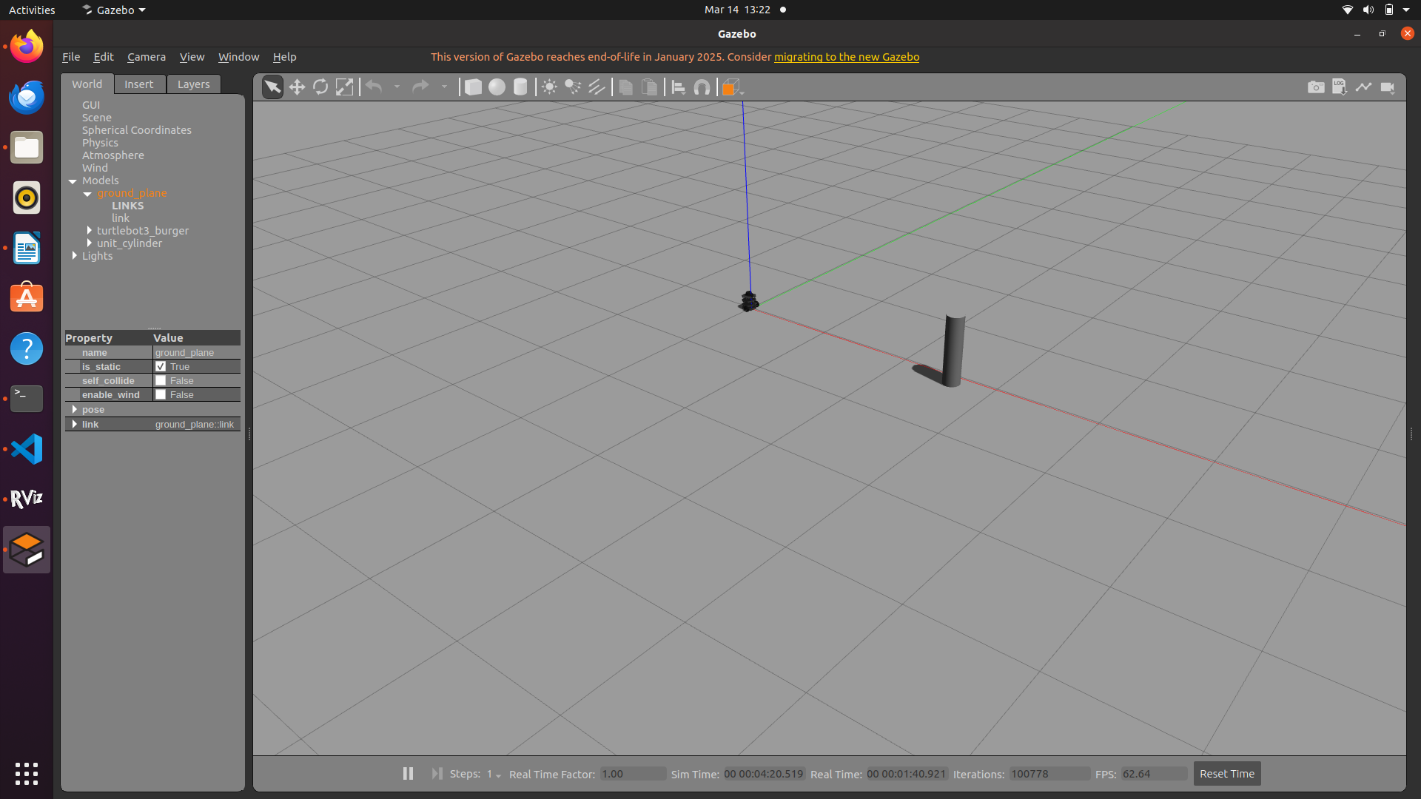
- Launch the move_base navigation stack:
roslaunch your_navigation_package move_base.launch
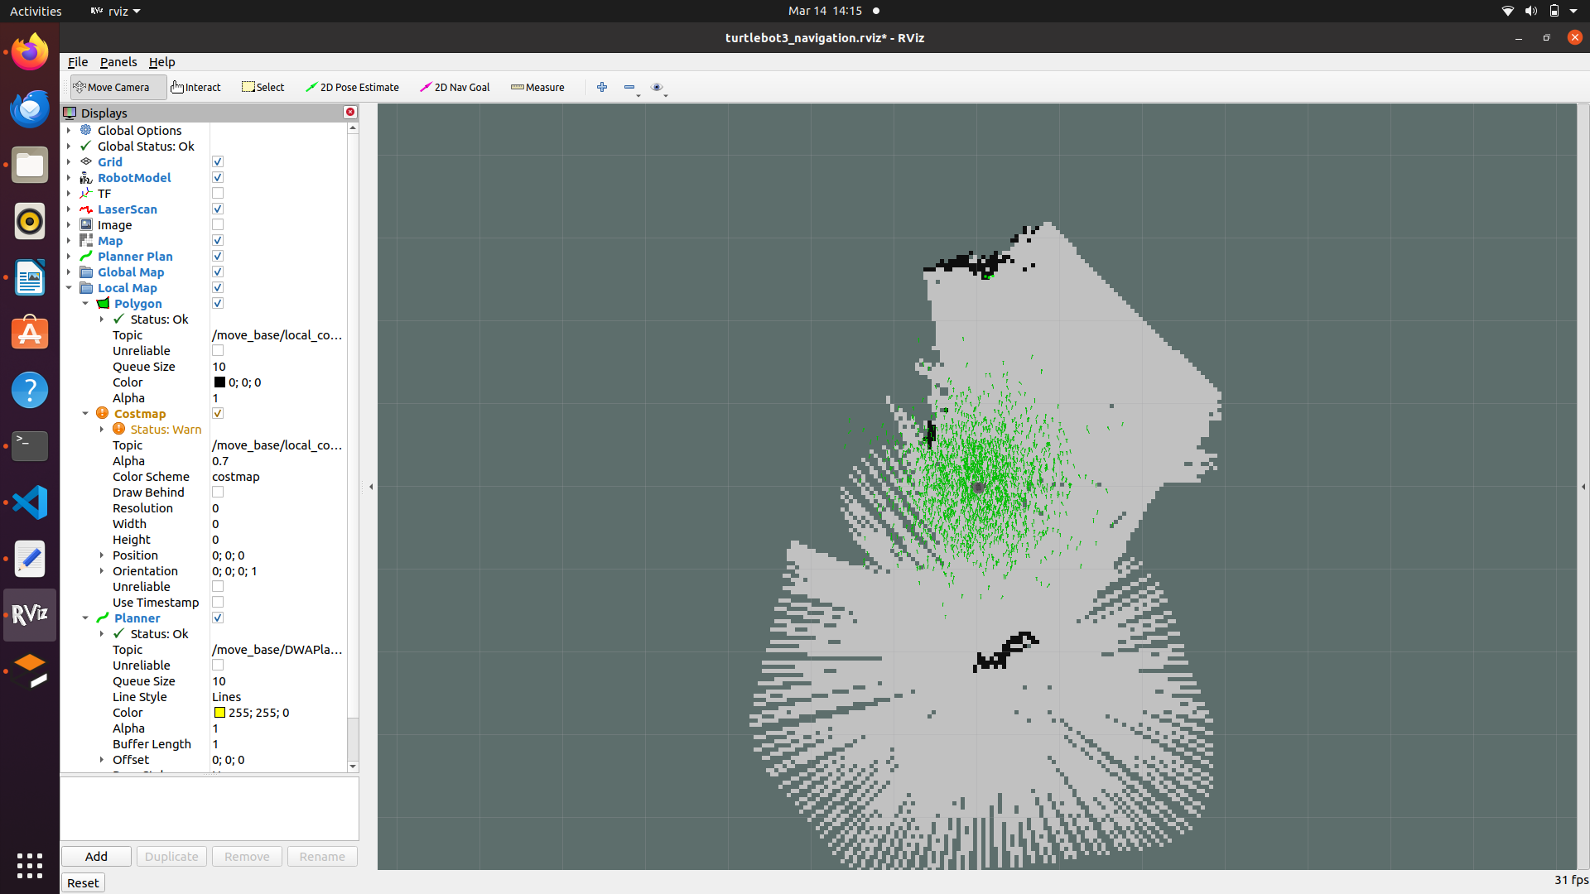

- Run the robot script:
./restro_robot.py
- Enter an order in the format:
table1, table2
  - The robot will first move to the kitchen.
  - It waits for user confirmation.
  - Then it proceeds to the listed tables.
  - Finally, it returns to the kitchen and then home.
- After completing an order, the system will ask if you want to place another order.

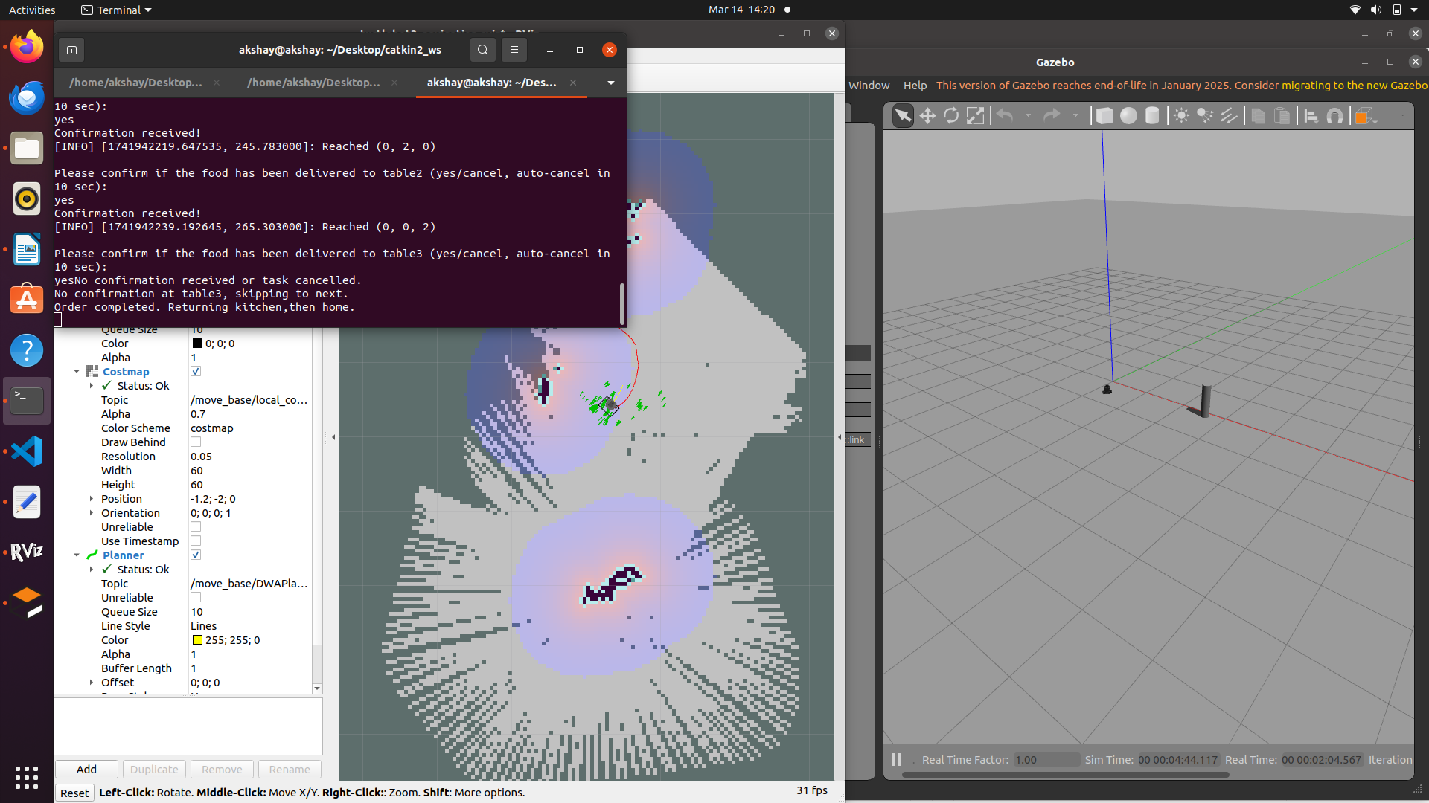

Configuration
The locations can be modified in the script under POSITIONS:
POSITIONS = {
"home": (0, 0, 0),
"kitchen": (2, 0, 0),
"table1": (2, 2, 0),
"table2": (0, 2, 0),
"table3": (0, 0, 2)
}
Adjust these (x, y, theta) values based on your map coordinates.

Troubleshooting
- If the robot does not move, ensure move_base is running correctly.
- If user input is not being captured, check if multithreading is causing conflicts.
- For ROS-related errors, use:
rostopic list
rostopic echo /move_base/status

Contributors
- Alishad Hussain (alishadhussain098@gamil.com)

Restaurant Robot Working Video

Description
This video demonstrates the working of a restaurant service robot, highlighting its navigation and order delivery process. The robot operates in a simulated restaurant environment, executing various tasks in different phases.

Workflow
The video consists of three phases:

Phase 1: Standard Order Delivery
- The world simulation is launched.
- The navigation platform is initialized.
- The robot executes the code to navigate between different locations.
- The robot follows this sequence:
  - Takes user input for order delivery.
  - Moves to the kitchen to collect the order.
  - Delivers the order to the respective tables.
  - Returns to the kitchen and then to its home position.

Phase 2: Handling Order Cancellations
- The robot processes a new set of orders.
- It follows the sequence:
  - Moves to the kitchen to collect the order.
  - Travels to Table 1, where the order is canceled, so it skips this table.
  - Moves to Table 2, where the order is confirmed and delivered successfully.
  - Moves to Table 3, waits for 10 seconds, but the order is eventually canceled.
  - Returns to the kitchen and then to its home position.

Phase 3: Early Order Cancellation
- The robot begins processing an order.
- While moving to the kitchen, the order gets canceled.
- The robot immediately returns to its home position without proceeding further.

Conclusion
This demonstration showcases the robot's ability to:
✅ Take user inputs for order processing.
✅ Navigate between the kitchen and tables efficiently.
✅ Handle order cancellations dynamically.
✅ Return to its home position after completing its tasks.

